2739. Total Distance Traveled

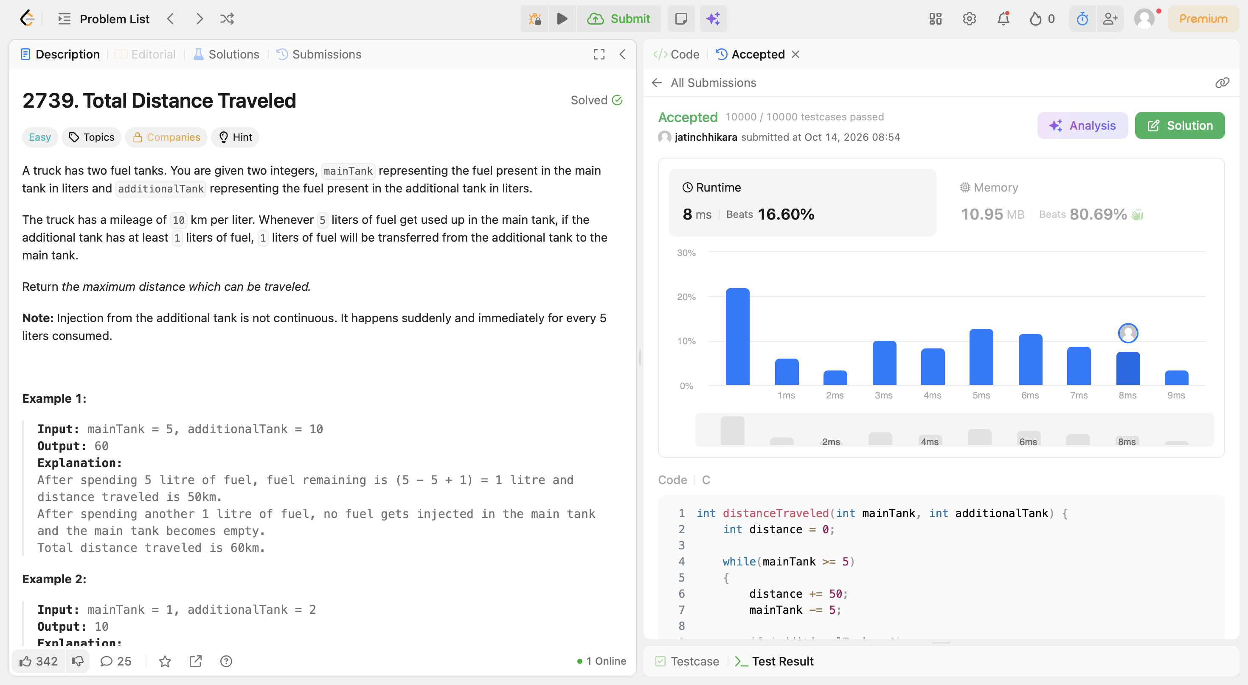
Code:
int distanceTraveled(int mainTank, int additionalTank) {
int distance = 0;

while(mainTank >= 5)
{
distance += 50;
mainTank -= 5;

if (additionalTank > 0)
{
mainTank++;
additionalTank--;
}
}

return distance + mainTank * 10;
}

